MECHANICAL DESIGN MANUAL SUMMARY SHEET

SUBJECT: Fire Protection Service Main Sizing

DESCRIPTION: Overview of the sizing of a fire protection water service main.

SPEC SECTION: 15310

APPLICABLE CODES: NFPA 13 – 2002 – Standard for the Installation of Sprinkler Systems

NFPA 14 – 2003 – Standard for the Installation of Standpipe, Private Hydrant, and Hose Systems.

DATE: February 2005

PREPARED BY: Fire Protection Committee (Tim Shimerdla)

Introduction

  - The purpose of the fire protection service main is to provide adequate water flow to meet applicable fire protection codes. The fire protection service main is sized based on the flow, available water pressure, and the associated pressure drop.

Information gathering

  - In order to size the fire protection main, code and water utility information is needed.

A. System type: Code dictates the sprinkler water densities, design areas, hose station pressures, etc. Some items you will need to determine:

- Is a sprinkler system required?
- Is the sprinkler wet or dry?
- Are there any in-rack sprinklers (high piled storage)?
- If a standpipe is required, is it automatic or manual, wet or dry?
- If a standpipe is required, is it Class I, Class II or Class III?
- If a standpipe is required, are the sprinklers and standpipe combined?
- Determine if a combined fire and domestic water service is acceptable.
- Does the project require FM Global or other insurance standards to be met?

*Verify all recommendations with the Authority Having Jurisdiction (AHJ).

  - Occupancy Hazard: For sprinkler systems, determine occupancy hazards for the building, i.e., Light, Ordinary (Group 1), Ordinary (Group 2), Extra (Group 1), or Extra (Group 2).

  - Hydrant Flow Test: Obtain hydrant flow data from the local utility for the closest hydrant to the fire service connection.

  - Service Pipe Routing: Approximate the service pipe route to determine the total equivalent length of pipe for piping pressure drop calculations.

  - Backflow Prevention: The backflow preventer type will be determined by the AHJ. Most fire departments typically use double check valve BFP’s. Typical pressure drop ranges for back flow preventers:

- Reduced Pressure Zone (RPZ): 2-1/2” & 3” 14 to 15 psig
3”, 4”, 6”, 8” & 10” 12 to 14 psig
- Double Check Valve All sizes 5 to 7 psig

Calculate Available Pressure

  - Calculate the total fire protection water demand.

    - Calculate the fire protection flow from the sprinklers, in GPM, based on location of greatest building flow demand (worst case hazard.)

Figure 11.2.3.1.5 Density/Area Curves.

- The fire protection service must satisfy one point on your respective curve. For conservative pipe size, pick the top point of the appropriate curve for your system (higher area/lower density). This will require the largest building sprinkler flow, but the lowest pressure required. Contractor will likely pick a lower point to reduce pipe size and cost (if pressure is available).

  - Verify the owner’s insurance company does not have different density coverage requirements from NFPA, such as owners insured by FM Global.

- Assume a 20%-30% overage to your calculated flow.

- NFPA 13 dictates possible exceptions to the design area without modifications to the density flow. Here are a few of the common ones:

  - In NFPA 13 (2002 ed.), section 11.2.3.2.3.1 allows the reduction of the design area if quick response sprinklers are used, ceiling heights are less then 20’, etc. (See Figure 11.2.3.2.3.1.)
  - As per NFPA 13 (2002 ed.), section 11.2.3.2.5: the area of sprinkler operation shall be increased by 30% for dry-pipe systems and double interlocked pre-action systems.
  - As per NFPA 13 (2002 ed.), section 11.2.3.2.4: the area of sprinkler operation shall be increased by 30% when using quick response sprinklers on sloped ceilings, with a pitch exceeding 1 in 6, in non-storage applications.

    - Determine hose stream allowance from NFPA 13, Table 11.2.3.1.1. Hose stream allowance is based on the building’s worst case hazard classification. All fire protection systems require a hose stream allowance. The inside hose stream comes from standpipes. The AHJ needs to determine the inside hose stream (50 or 100 gpm) and the water supply duration for fighting a fire. The total combined inside and outside hose stream is the value used to determine the total fire flow. The inside hose stream will be used in determining the flow through the fire service main.

In systems where there are no standpipes, the inside hose stream is 0 gpm. In these systems, the total combined inside and outside hose stream still needs to be included in determining the total fire flow. The hose stream would still come from a source outside the building. It could come from a fire hydrant off of the city water main or from a private hydrant off the fire service main. In the private hydrant case, flow would need to be accounted for in the fire service main flow.

Table 11.2.3.1.1 Hose Stream Demand and Water Supply duration Requirements for Hydraulically Calculated Systems.

Occupancy or Commodity Classification | Inside Hose (gpm) | Total Combined Inside and Outside Hose (gpm) | Duration (minutes)
Light Hazard | 0, 50 or 100 | 100 | 30
Ordinary Hazard | 0, 50 or 100 | 250 | 60-90
Extra Hazard | 0, 50 or 100 | 500 | 90-120

    - Total fire flow = building sprinkler flow + combined hose streams.

    - Fire service main flow = building sprinkler flow + inside hose streams + “other” (private hydrant, etc.)

  - Calculate the individual sprinkler flow with the greatest demand, using the density/area curves and the tables in NFPA 13 for sprinkler protection area for types of sprinklers.

- Individual sprinkler flow, Q_{s} (gpm), = Sprinkler flow density (gpm/ft²) * Sprinkler protection Area (ft²)

Below is an example of a specific sprinkler type, taken from NFPA 13, section 8.6.2.2.1. The maximum allowable protection area and maximum distance between standard spray pendent sprinklers is indicated in the following table:

Table 8.6.2.2.1(b) Protection Areas and Maximum Spacing (Standard Spray Upright/ Standard Spray Pendent) for Ordinary Hazard

Protection Area Spacing (maximum)

Construction Type System Type ft² m² ft m
All All 130 12.1 15 4.6

  - Calculate the available pressure for the main.

- Determine the fire protection service residual pressure at the demand flow. Using the hydrant flow characteristics, plot the hydrant flow test data on a hydraulic graph. Find the required fire flow, including hose streams, from the graph to determine the available residual pressure.

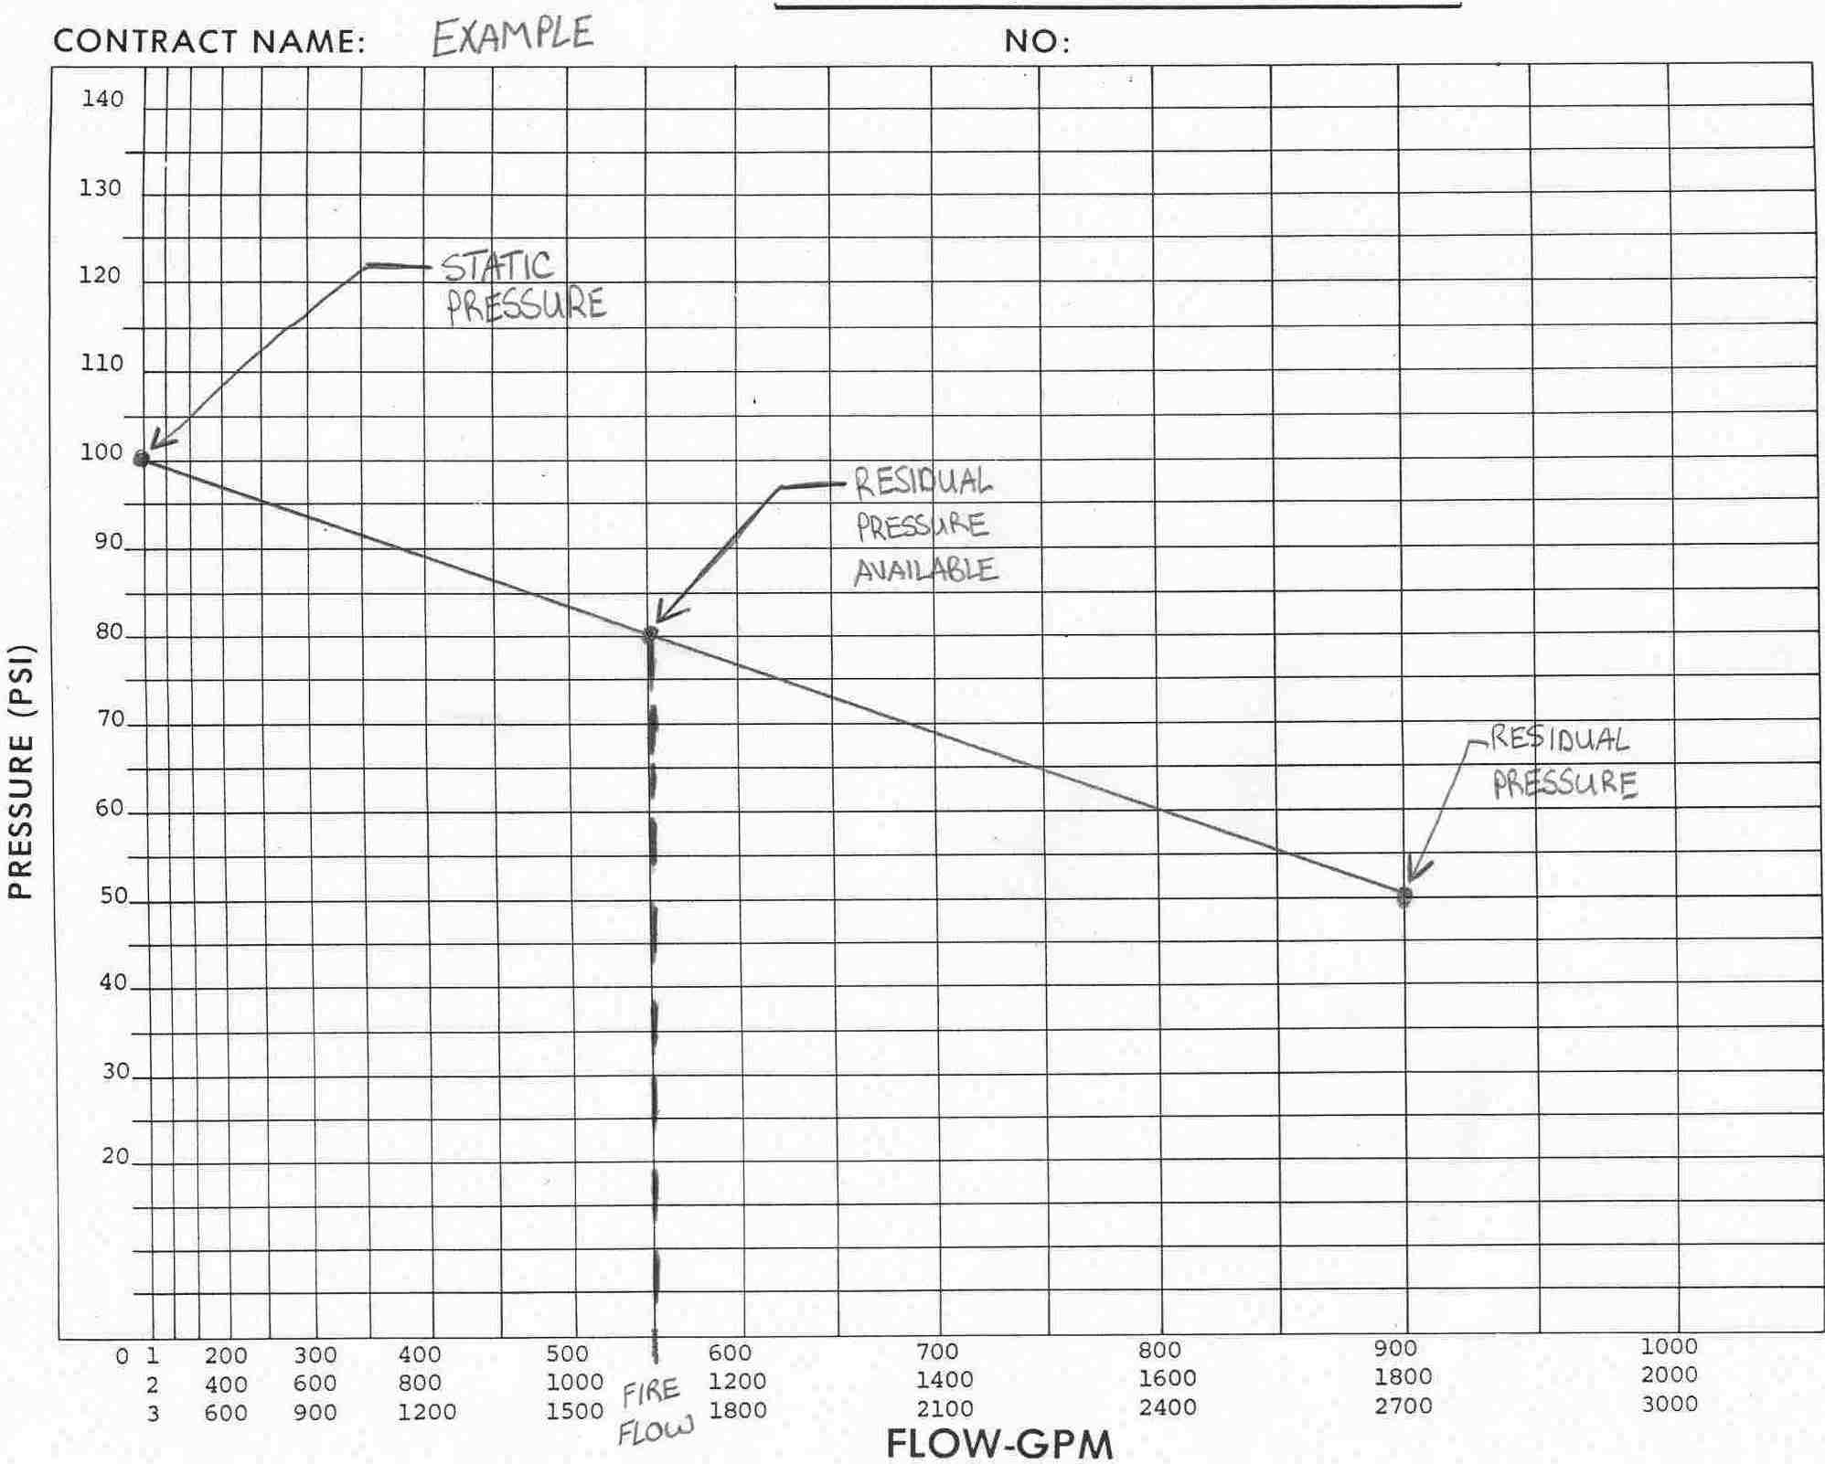

Note: Subtract 5 psi from the available residual pressure as a safety factor. 5 psi is in our specifications and is the industry standard. However, a greater safety factor may be warranted in rapidly developing areas or areas where we know water demand will greatly increase in the future.
- Calculate Pressure Requirements

  - Calculate the total pressure needed at the most remote sprinkler (sprinkler with greatest demand) or hose outlet (for automatic standpipes).

For hydraulically designed standpipes, the desired flow rate at the outlet of the hydraulically most remote hose station must be supplied at a minimum of 100 psig (65 psig in some codes) residual pressure. This will typically require a fire pump. Verify local city main water pressures.

For sprinklers, the following formula applies:

Q_{s} = K (psig)^{1/2} (Or, psig = (Q_{s}/K)² )

Where, Q_{s} = Individual sprinkler flow in gpm.
K = Coefficient of sprinkler orifice (See Below)
psig = Pressure required at sprinkler

Typical sprinkler K factors

Orifice Size | K
½” | 5.6
¾” | 8.1
ELO (extra large orifice) | 11.4

Note: Code minimum for any sprinkler is 7 psig. All sprinklers have a required minimum pressure; some are greater than 7 psig. In general, 10-20 psig is needed at sprinklers.

  - Calculate the system pressure loss.

- Determine the static pressure loss from the highest sprinkler or hose connection to the hydrant pressure from the flow test. (0.433 psig = 1’)

- Estimate the pressure drop due to pipe friction from the flange of the entering service pipe to the most remote sprinkler or hose connection.

Note: 10 to 20 psig is typical. Use 20 psig to be conservative. Pipes can typically be oversized to meet 10 psig.

- Determine the loss for the backflow preventor. (Consult manufacturer’s data)

- The total system pressure loss = static pressure loss + pipe friction loss + backflow preventor loss.

  - Determine the pressure loss due to friction for the fire service main.

  - Use the Hazen-Williams equation to determine the pressure loss:

P (psig/ft) = 4.52 x Q^{1.85}
C^{1.85} x D^{4.87}
Where, Q = Flow through the main, gpm
D = Inside diameter of service main, inches
C = Hazen-Williams Flow Coefficient (Based on pipe material)

Note: The selection of the proper Hazen-Williams coefficient is important. NFPA 13 gives maximum coefficients for given pipe types. New unlined steel pipe has a Hazen-Williams coefficient close to 140. However, it quickly deteriorates to 130 and, after a few years of use, to 120. Hence, code requires a coefficient of 120 for steel-piped wet systems. A Hazen-Williams coefficient of 100 is required for dry pipe systems because of the increased tendency for deposits and corrosion in these systems. However, it should be realized that a new system will have fewer line losses than calculated, and the distribution pattern will be affected accordingly. Conservatism can also be built into systems by intentionally designing to a lower Hazen-Williams coefficient than that indicated. Below are the code required maximum values for these flow coefficients.

Typical Flow Coefficients
Material | C
Unlined Cast Iron or Ductile | 100
Black Steel (dry) | 100
Black Steel (wet) | 120
Galvanized | 120
Lined Cast Iron or Ductile | 140
Plastic | 150

  - Determine the equivalent length of pipe to calculate the fire service main pressure drop. Start at the connection to the water supply. The Fire Pump Piping Pressure Drop Form (Standard Mechanical Design Form F-3) can be used to determine the pressure drop. A good rule of thumb to determine the equivalent length, including fittings = Length of main (ft) * 1.5.

Size the Service main

  - The total pressure required = system pressure drop + fire service main pressure drop + pressure required at most remote sprinkler or hose connection

  - If the total pressure required is greater than the available pressure (taking into account the 5 psig reduction of residual pressure), increase the fire service main size to reduce the pressure needed to overcome the friction in the main. If this is not possible, then a fire pump is required.

- Example

A new, 4-story building for Company “X” will be built in Des Moines, Iowa. It will require a wet sprinkler system, with a manual-wet Class I standpipe system. Most of the building is a light occupancy hazard, but there are ordinary (Group 1) hazards inside the building. The equivalent length of the fire service main is calculated at 300’.

After discussion with the AHJ, the inside hose stream will be 100 gpm and the pressure requirements at the most remote hose connection of the manual-wet standpipe will be zero. (In a fire situation, the fire department will use its connection to meet the pressure requirement).

The exterior hose connections are not fed by the fire service main. The height above the pressure hydrant is roughly 48’.

  - Fire protection water demand for building “X”.

Ordinary Hazard (Group 1): 0.10 (gpm/ft²) * 4000 (ft²)

0.10 * 4000 = 400 gpm

400 gpm
X 1.3 (Assumption for flow overage)
520 gpm (Building sprinkler flow)
+ 250 gpm (Combined inside and outside hose stream)
Total Fire Flow: 770 gpm

520 gpm (Building sprinkler flow)
+ 100 gpm (Inside hose stream)
Fire Main Service Flow: 620 gpm

Individual Sprinkler flow: Q (gpm) = [Sprinkler flow density, gpm/ft², (Ordinary hazard, group 1)] X [Sprinkler protection area, ft², (Standard pendant for ordinary hazard)]

Q = 0.10 (gpm/ft²) X 130 (ft²) = 13 gpm

  - Available pressure for the main (Data taken from a hydrant flow test, performed by the fire department.)

Static pressure: 80 psig
Residual pressure: 70 psig (at 900 gpm flow)

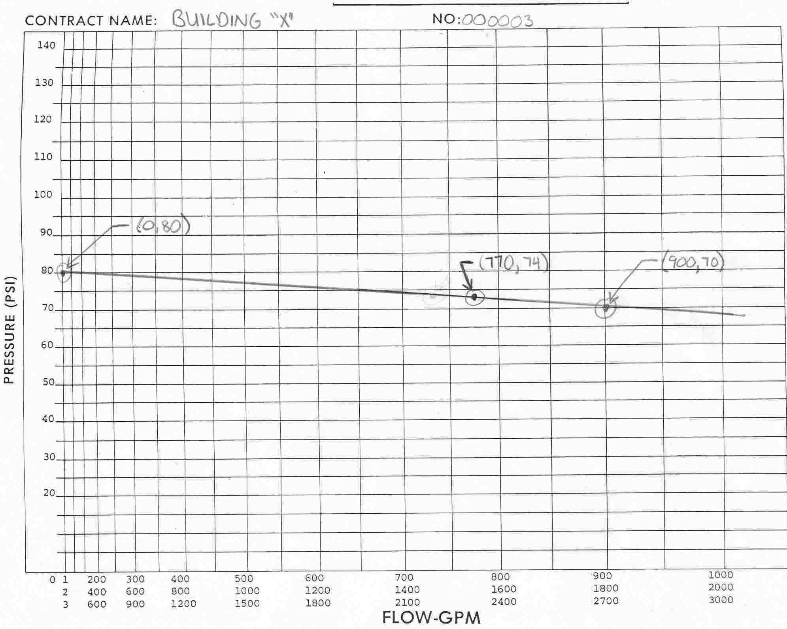

From the hydraulic graph, 74 psi–5psi (safety factor) = 69 psi available residual pressure.

Note: If this system was selected as an automatic standpipe system, with a pressure requirement of 100 psig at the outlet a fire pump would be needed. Refer to the fire pump sizing guideline for additional information on complete fire pump systems.

  - Sprinkler pressure required.

Psig = (Q/K)²

For a ½” sprinkler: Psig = (13 gpm/5.6)² = 5.4 psig.

*The code minimum pressure required for a sprinkler is 7 psig.

  - System pressure loss

A. Static pressure loss above pressure hydrant: 48’ X 0.433 psi/1’ = 20.8 psig
B. Estimate of pipe friction in the system, (typical): 20 psig
C. Back Flow Preventor, (Double Check): 7 psig
47.8 psig

  - Determine the pressure loss for the fire service main.

Use the Hazen-Williams equation, to determine the diameter of the main. Diameter (D) = 4” (inside diameter), Galvanized steel service pipe.

P (psig/ft) = 4.52 x (620)^{1.85}
(120)^{1.85} x (4)^{4.87}

P (psig/ft) = 0.11 psig/ft

Pressure loss for main: 0.11 psig/ft * 300’ = 33 psig

  - Total pressure required: 7 psig (Sprinkler pressure required)
+ 47.8 psig (System pressure loss)
+ 33 psig (Pressure loss for fire main)

Required: 87.8 psig

Residual pressure available: 69 psig

A 4” diameter fire service main won’t work

  - Iterate using Diameter (D) = 6” (inside diameter), Galvanized service pipe.

P (psig/ft) = 4.52 x (620)^{1.85}
(120)^{1.85} x (6)^{4.87}

P (psig/ft) = 0.015 psig/ft

Pressure loss for main: 0.015 psig/ft * 300’ = 4.6 psig

  - Total pressure required: 7 psig (Sprinkler pressure required)
+ 47.8 psig (System pressure loss)
+ 4.6 psig (Pressure loss for fire main)

59.4 psig

Residual pressure available: 69 psig

A 6” diameter fire service main will work. A fire pump is not required.

FIRE PROTECTION SERVICE MAIN SIZING WORKSHEET

AVAILABLE PRESSURE

- Fire flow water demand

- Density x Density area x 130% = ________ gpm

- Hose Stream Demand = ________ gpm

- Other = ________ gpm

Total Fire Flow = ________ gpm

- AVAILABLE PRESSURE at fire flow = ________ psig

PRESSURE REQUIRED

- Water pressure requirements

  - Pressure required at sprinklers (or hose) = ________ psig

  - Static loss (elevation) = ________ psig

  - System friction loss = ________ psig

  - Backflow preventor loss = ________ psig

  - Fire main friction loss = ________ psig

- PRESSURE REQUIRED at fire flow = ________ psig

AVAILABLE PRESSURE – PRESSURE REQUIRED = ________ psig

DESIGN FIRE PROTECTION SERVICE MAIN SIZE = ________ Inches

